**Parallel Computing**

R provides a number of convenient facilities for parallel computing. The following method shows you how to setup and run a parallel process on your current multi-core device, without need for additional hardware.

**Setting up for parallelization**

The number of parallel processes you can run simultaneously depends on the number of cores in your machine. If you are on a Windows PC, open ‘Task Manager’ => ‘Performance’ tab, and count the number of boxes below “CPU Usage History”. That is the maximum number of parallel processes you can run in your computer. You can practically use all of them for R computations, however, it is a good idea to leave out a core or two for background system processes. Here is how you can set up your R session for parallel processing:

# Registering cores for parallel process

library(doSNOW)

cl <- makeCluster(4, type="SOCK") # 4 – number of cores

registerDoSNOW(cl) # Register back end Cores for Parallel Computing

**Running the parallel process**

Once the cores are set up to run computations in parallel, the ‘foreach’ loop (from foreach package) can run your functions in parallel by opening as many parallel R session as the number of cores you have registered. The difference between a regular for-loop and for-each loop is, the for-loop runs serially, i.e. your loop processes one value of loop-counter (i) at a time. While in for-each, the arguments you supply to the loop-counter (‘i’ in this case) will be run simultaneously at {number_of_cores_initialised} number of processes at a time. After running the functions defined inside the loop, it combines all the returned values based on the function supplied to the ‘.combine‘ argument.

**Parallel processing: some simple examples**

In the examples below, replace %dopar% with %do% to make it run as a non-parallel process.

**Example 1**

library(foreach)

foreach(i = 1:28) %dopar% {sqrt(i)} # example 1

**Example 2**

# returned output values of the parallel process are combined using 'c()' function

foreach(i = 1:28,.combine = "c") %dopar% {sqrt(i)} # example 2

**Example 3**

# returned output values of the parallel process are combined using 'cbind()' function

foreach(i = 1:28,.combine = "cbind") %dopar% {letters[1:4]} # example 3

**Example 4**

You can also create your own combining function as you wish.

# combine using your custom defined function: "myCustomFunc()" and store in 'output' variable

output <- foreach(i = 1:28, .combine = "myCustomFunc") %dopar% {

sqrt(i)

}

myCustomFunc above is just a placeholder. ## Further Customizing for packages and output aggregation

You are nearly there, just a couple more things left. If you are using functions from packages loaded to your global R environment, they may not work inside the for-each loop, because, multiple R sessions are instantiated for each parallel process. So you need to define the packages you need inside the foreach loop in the .packages argument. Additionally, if you have a set of variables to iterate over in a separate R object (like a data frame), you can even pass it as a separate iterating variable (allRowIndices) in this case, in the foreach statement. Here is a sample of the code to show how it might look like.

**Structure of a typical parallel processing code**

allRowIndices <- c(1:nrow(inputData)) # assign row indices of inputData, that will be processed in parallel

output <- foreach (rowNum = allRowIndices, .combine = rbind, .packages = c("caret", "ggplot2", "Hmisc")) %dopar% {

# code to process each rowNum goes within this block.

# 'n' rows will be processed simultaneously, where 'n' is number of registered cores.

# after processing all rows, the returned value is combined using the function defined in `.combine` argument `rbind` in this case. The output thus aggregated is stored in output variable.

# Finally, the packages required by functions in this block has to be mentioned within .packages argument.

}

stopCluster(cl) # undo the parallel processing setup

In the above code, the main component of parallelisation is the foreach loop and the three arguments that go along with it. The first argument (rownum) here is a row counter that iterates through all the rows in ‘allRowIndices’. The second one, ‘.combine’ is a function that will be used to aggregate the results of all computations from the rows. In this case, ‘rbind’ will be used to append the results in rows. Finally, the third one ‘.packages’, states which all packages will be needed for the functions used within the ‘foreach’ block. Note that, even if you have already included the packages before calling the ‘foreach’, you need to re-specify within this block, since, new R sessions will be opened for the parallel processing. With all these defined, the computations will be done in parallel based on the number of cores you had registered earlier and the results get combined and stored in output.

**A comparison between parallel and non-parallel process**

To demonstrate the processing times, a simple math operation is performed on each row of a 4-columned matrix created below. The time taken by a parallel vs non-parallel process is compared as the number of rows in inputData is gradually increased.

inputData <- matrix(1:800000, ncol=4) # prepare input data

head(inputData)

#> [,1] [,2] [,3] [,4]

#> [1,] 1 200001 400001 600001

#> [2,] 2 200002 400002 600002

#> [3,] 3 200003 400003 600003

#> [4,] 4 200004 400004 600004

#> [5,] 5 200005 400005 600005

#> [6,] 6 200006 400006 600006

# For each row of inputData, we'll compute the output as follows:

row output = col1 * col2 + col3 / col4

**1. Non-parallel version**

output_serial <- numeric() # initialize output

for (rowNum in c(1:nrow(inputData))) {

calculatedOutput <- inputData[rowNum, 1] * inputData[rowNum, 2] + inputData[rowNum, 3] / inputData[rowNum, 4] # compute output

output_serial <- c(output_serial, calculatedOutput) # append to output variable

}

**2. Parallel version**

library(doSNOW)

cl <- makeCluster(4, type="SOCK") # 4 – number of cores

registerDoSNOW(cl) # Register Backend Cores for Parallel Computing

allRowIndices <- c(1:nrow(inputData)) # row numbers of inputData, that will be processed in parallel

output_parallel <- foreach (rowNum = allRowIndices, .combine = c) %dopar% {

calculatedOutput <- inputData[rowNum, 1] * inputData[rowNum, 2] + inputData[rowNum, 3] / inputData[rowNum, 4] # compute output

return (calculatedOutput)

}

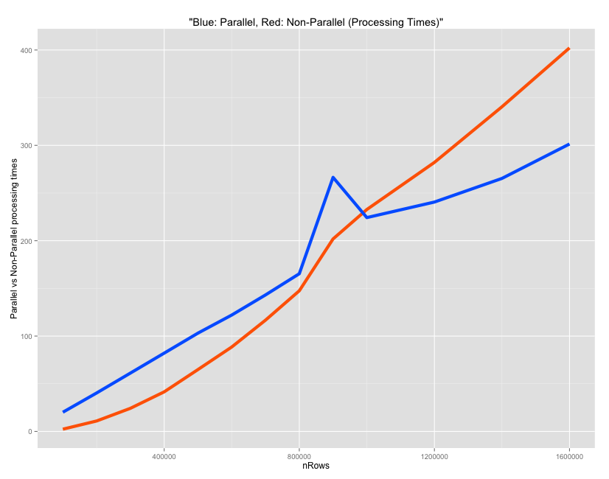

###############################################################################################

**Strategies to Speed-up R Code**

The for-loop in R, can be very slow in its raw un-optimized form, especially when dealing with larger data sets. There are a number of ways you can make your logics run fast, but you will be really surprised how fast you can actually go. This chapter shows a number of approaches including simple tweaks to logic design, parallel processing and Rcpp, increasing the speed by orders of several magnitudes, so you can comfortably process data as large as 100 Million rows and more.

Lets try to improve the speed of a logic that involves a for-loop and a condition checking statement (if-else) to create a column that gets appended to the input data frame (df). The code below creates that initial input data frame.

# Create the data frame

col1 <- runif (12^5, 0, 2)

col2 <- rnorm (12^5, 0, 2)

col3 <- rpois (12^5, 3)

col4 <- rchisq (12^5, 2)

df <- data.frame (col1, col2, col3, col4)

df

#> col1 col2 col3 col4

#> 1 0.6155322 -2.91525449 2 6.12523968

#> 2 0.5153450 -5.81655916 6 2.97873584

#> 3 1.1046449 0.80309503 2 0.07266261

#> 4 0.1127663 -1.48824042 3 2.39918101

#> 5 0.9370986 -1.35786823 0 7.38580513

#> 6 0.9675415 0.05832758 2 1.17428455

**The logic we are about to optimize:**

For every row on this data frame df, check if the sum of all values is greater than 4. If it is, a new 5th variable gets the value greater_than_4, else, it gets lesser_than_4.

# Original R code: Before vectorization and pre-allocation

system.time({

for (i in 1:nrow(df)) { # for every row

if ((df[i, 'col1'] + df[i, 'col2'] + df[i, 'col3'] + df[i, 'col4']) > 4) { # check if > 4

df[i, 5] <- "greater_than_4" # assign 5th column

} else {

df[i, 5] <- "lesser_than_4" # assign 5th column

}

}

})

head(df)

#> col1 col2 col3 col4 V5

#> 1 0.6155322 -2.91525449 2 6.12523968 greater_than_4

#> 2 0.5153450 -5.81655916 6 2.97873584 lesser_than_4

#> 3 1.1046449 0.80309503 2 0.07266261 lesser_than_4

#> 4 0.1127663 -1.48824042 3 2.39918101 greater_than_4

#> 5 0.9370986 -1.35786823 0 7.38580513 greater_than_4

#> 6 0.9675415 0.05832758 2 1.17428455 greater_than_4

All the approaches we see below re-creates the same logic but will do it more efficiently.

All the computations below, for processing times, were done on a MAC OS X with 2.6 Ghz processor and 8GB RAM.

**1. Vectorize and Pre-allocate**

Always initialize your data structures and output variable to required length and data type before taking it to loop for computations. Try not to incrementally increase the size of your data inside the loop. Lets compare how vectorization improves speed on a range of data sizes from 1000 to 100,000 rows.

# After vectorization and pre-allocation

output <- character (nrow(df)) # initialize output vector

system.time({

for (i in 1:nrow(df)) {

if ((df[i, 'col1'] + df[i, 'col2'] + df[i, 'col3'] + df[i, 'col4']) > 4) {

output[i] <- "greater_than_4" # assign to vector

} else {

output[i] <- "lesser_than_4"

}

}

df$output <- output # finally assign to data frame

})

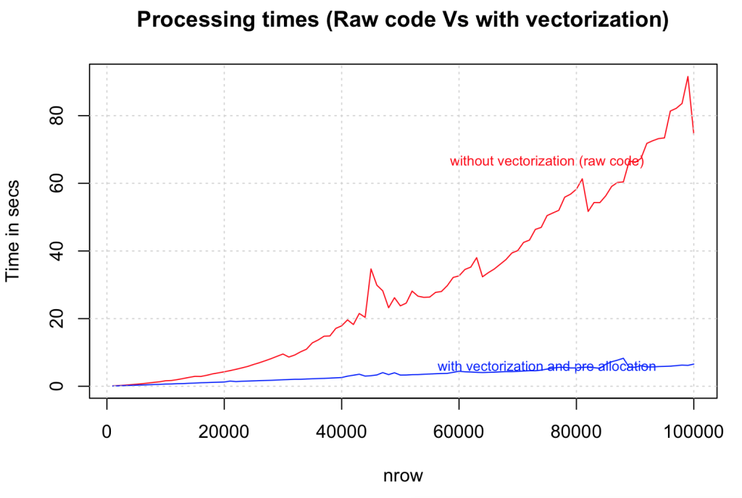

**2. Take statements that check for conditions (if statements) outside the loop**

Taking the condition checking outside the loop the speed is compared against the previous version that had vectorization alone. The tests were done on dataset size range from 100,000 to 1,000,000 rows. The gain in speed is again dramatic.

# After vectorization and pre-allocation, taking the condition checking outside the loop.

output <- character (nrow(df))

condition <- (df$col1 + df$col2 + df$col3 + df$col4) > 4 # condition check outside the loop

system.time({

for (i in 1:nrow(df)) {

if (condition[i]) {

output[i] <- "greater_than_4"

} else {

output[i] <- "lesser_than_4"

}

}

df$output <- output

})

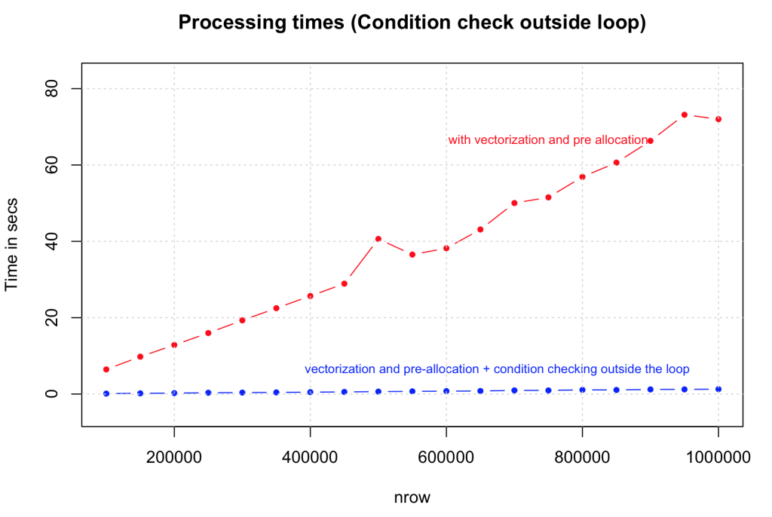

**3. Run the loop only for True conditions**

Another optimization we can do here is to run the loop only for condition cases that are ‘True’, by initializing (pre-allocating) the default value of output vector to that of ‘False’ state. The speed improvement here largely depends on the proportion of ‘True’ cases in your data. The tests compared the performance of this against the previous case (2) on data size ranging from 1,000,000 to 10,000,000 rows. Note that we have increase a ‘0’ here. As expected there is a consistent and considerable improvement.

output <- character(nrow(df))

condition <- (df$col1 + df$col2 + df$col3 + df$col4) > 4

system.time({

for (i in (1:nrow(df))[condition]) { # run loop only for true conditions

if (condition[i]) {

output[i] <- "greater_than_4"

} else {

output[i] <- "lesser_than_4"

}

}

df$output })

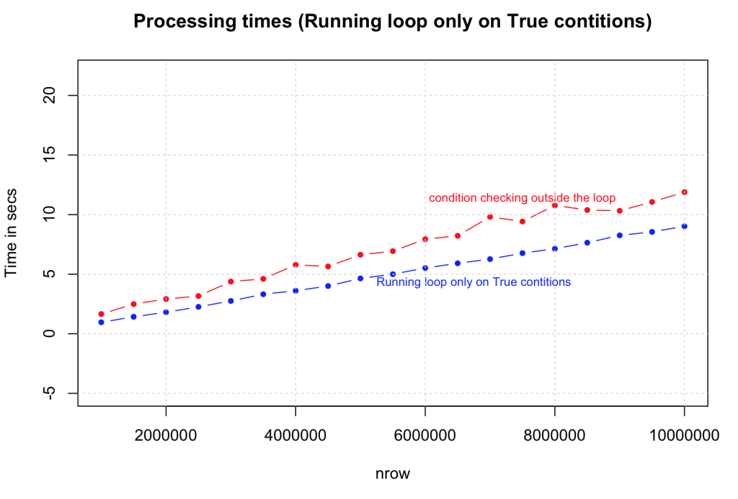

**4. Use ifelse() whenever possible**

You can make this logic much simpler and faster by using the ifelse() statement. The syntax is similar to the ‘if’ function in MS Excel, but the speed increase is phenomenal, especially considering that there is no vector pre-allocation here and the condition is checked in every case. Looks like this is going to be a highly preferred option to speed up simple loops.

system.time({

output <- ifelse ((df$col1 + df$col2 + df$col3 + df$col4) > 4, "greater_than_4", "lesser_than_4")

df$output <- output

})

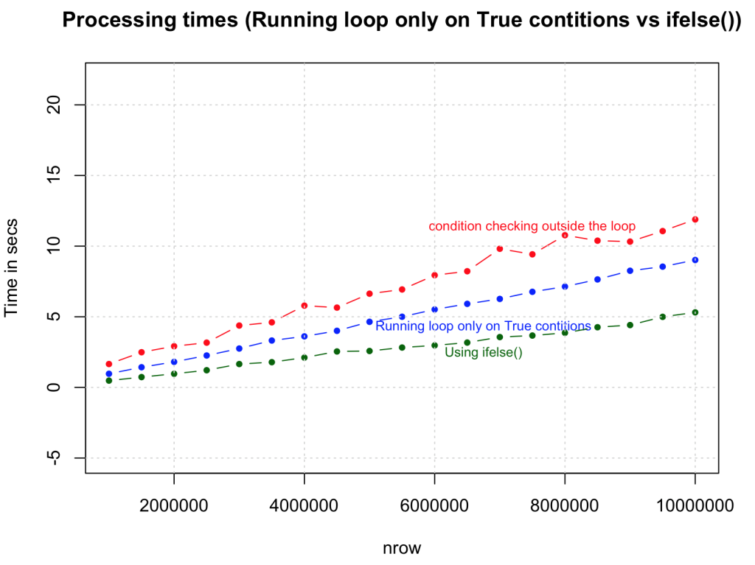

**5. Using which()**

By using which() command to select the rows, we are able to achieve one-third the speed of Rcpp.

system.time({

want = which(rowSums(df) > 4)

output = rep("less than 4", times = nrow(df))

output[want] = "greater than 4"

})

# nrow = 3 Million rows (approx)

#> user system elapsed

#> 0.396 0.074 0.481

**6. Use apply family of functions instead of for-loops.**

Using apply() function to compute the same logic and comparing it against the vectorized for-loop. The results again is faster in order of magnitudes but slower than ifelse() and the version where condition checking was done outside the loop. This can be very useful, but you will need to be a bit crafty when handling complex logic.

# apply family

system.time({

myfunc <- function(x) {

if ((x['col1'] + x['col2'] + x['col3'] + x['col4']) > 4) {

"greater_than_4"

} else {

"lesser_than_4"

}

}

output <- apply(df[, c(1:4)], 1, FUN=myfunc) # apply 'myfunc' on every row

df$output <- output

})

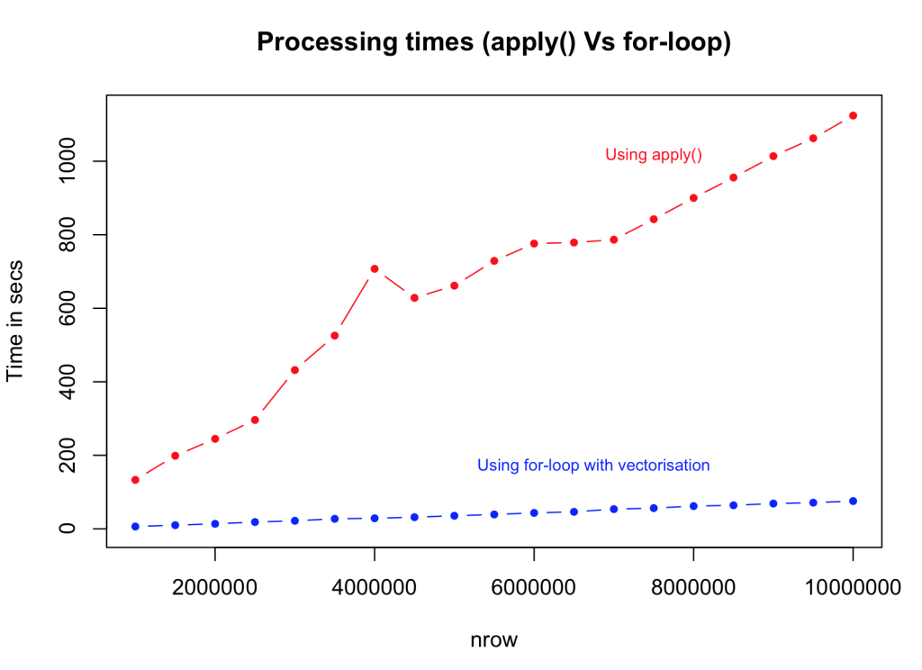

**7. Use byte code compilation for functions cmpfun() from compiler package, rather than the actual function itself.**

This may not be the best example to illustrate the effectiveness of byte code compilation, as the time taken is marginally higher than the regular form. However, for more complex functions, byte-code compilation is known to perform faster. So you should definitely give it a shot.

# byte code compilation

library(compiler)

myFuncCmp <- cmpfun(myfunc)

system.time({

output <- apply(df[, c (1:4)], 1, FUN=myFuncCmp)

})

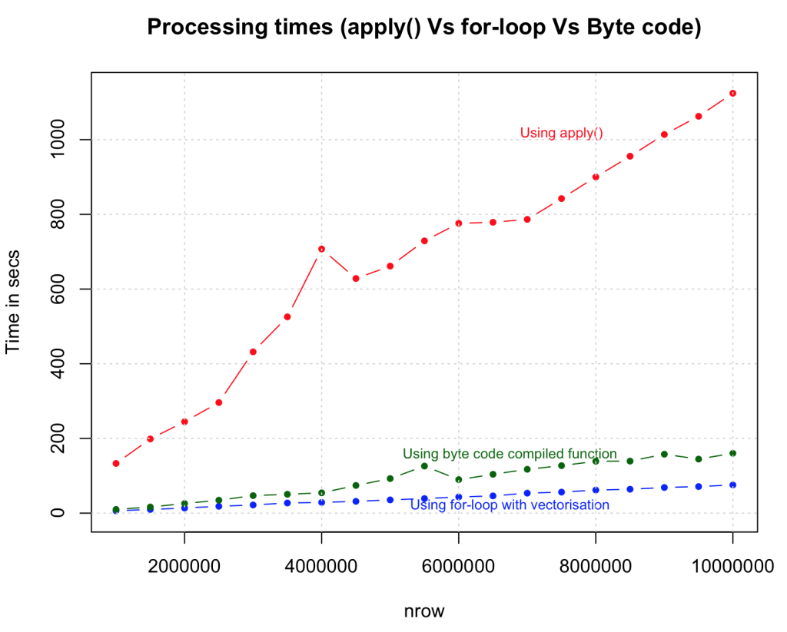

**8. Use Rcpp**

Lets turn this up a notch. So far we have gained speed and capacity by various strategies and found the most optimal one using the ifelse() statement. What if we add one more zero? Below we execute the same logic but with Rcpp, and with a data size is increased to 100 Million rows. We will compare the speed of Rcpp to the ifelse() method.

library(Rcpp)

sourceCpp("MyFunc.cpp")

system.time (output <- myFunc(df)) # see Rcpp function below

Below is the same logic executed in C++ code using Rcpp package. Save the code below as “MyFunc.cpp” in your R session’s working directory (else you just have to sourceCpp from the full file path). Note: the // [[Rcpp::export]] comment is mandatory and has to be placed just before the function that you want to execute from R.

// Source for MyFunc.cpp

#include <Rcpp.h>

using namespace Rcpp;

// [[Rcpp::export]]

CharacterVector myFunc(DataFrame x) {

NumericVector col1 = as<NumericVector>(x["col1"]);

NumericVector col2 = as<NumericVector>(x["col2"]);

NumericVector col3 = as<NumericVector>(x["col3"]);

NumericVector col4 = as<NumericVector>(x["col4"]);

int n = col1.size();

CharacterVector out(n);

for (int i=0; i<n; i++) {

double tempOut = col1[i] + col2[i] + col3[i] + col4[i];

if (tempOut > 4){

out[i] = "greater_than_4";

} else {

out[i] = "lesser_than_4";

}

}

return out;

}

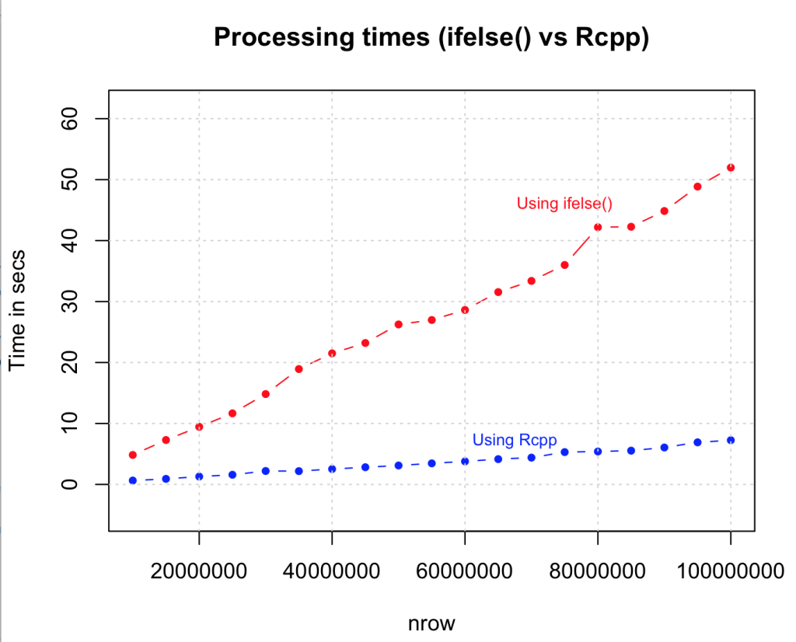

**9. Use parallel processing if you have a multicore machine.**

# parallel processing

library(foreach)

library(doSNOW)

cl <- makeCluster(4, type="SOCK") # for 4 cores machine

registerDoSNOW (cl)

condition <- (df$col1 + df$col2 + df$col3 + df$col4) > 4

# parallelization with vectorization

system.time({

output <- foreach(i = 1:nrow(df), .combine=c) %dopar% {

if (condition[i]) {

return("greater_than_4")

} else {

return("lesser_than_4")

}

}

})

df$output <- output

**10. Remove variables and flush memory as early as possible.**

Remove objects rm() that are no longer needed, as early as possible in code, especially before going in to lengthy loop operations. Sometimes, flushing gc() at the end of each iteration with in the loops can help.

**11. Use data structures that consume less memory**

data.table() is an excellent example, as it reduces the memory overload which helps to speed up operations like merging data.

dt <- data.table(df) # create the data.table

system.time({

for (i in 1:nrow (dt)) {

if ((dt[i, col1] + dt[i, col2] + dt[i, col3] + dt[i, col4]) > 4) {

dt[i, col5:="greater_than_4"] # assign the output as 5th column

} else {

dt[i, col5:="lesser_than_4"] # assign the output as 5th column

}

}

})

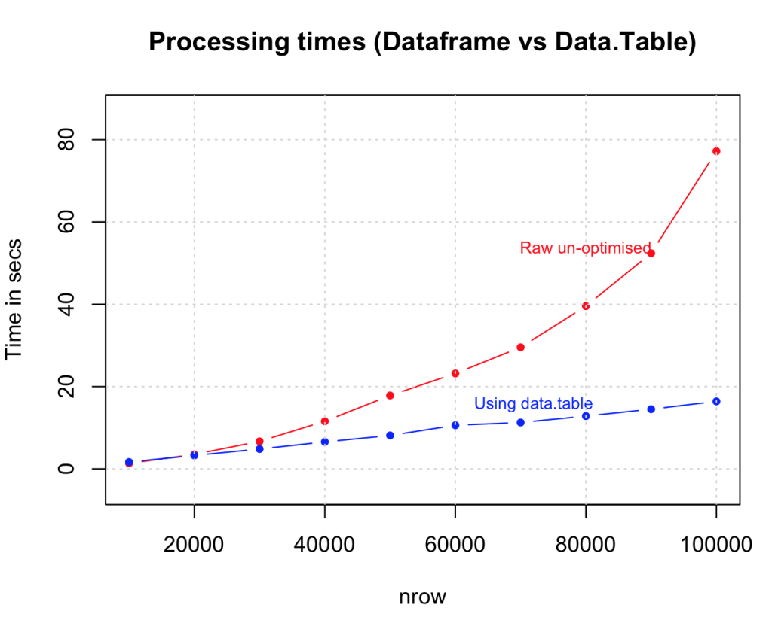

**Summary**

| **Method** | **Speed** | **nrow(df)/time_taken = *n* rows per second** |
| --- | --- | --- |
| Raw | 1X | 120000/140.15 = 856.2255 rows per second (normalized to 1) |
| Vectorized | 738X | 120000/0.19 = 631578.9 rows per second |
| True Conditions only | 1002X | 120000/0.14 = 857142.9 rows per second |
| ifelse | 1752X | 1200000/0.78 = 1500000 rows per second |
| which | 8806X | 2985984/0.396 = 7540364 rows per second |
| Rcpp | 13476X | 1200000/0.09 = 11538462 rows per second |

The numbers above are approximate and are based in arbitrary runs. The results are not calculated for data.table(), byte code compilation and parallelisation methods as they will vary on a case to case basis, depending upon how you apply it.